Workbook

Designing and Justifying an Industry-Grade AI Commerce Assistant
(RAG + Tools + LCEL + VectorDB + OpenAI)

Purpose of This Workbook
This workbook is designed to guide teams through structured decision-making before building a production-grade AI Commerce Assistant.
By the end, teams should be able to:
- Define a clear problem statement
- Select appropriate LLMs
- Choose embedding models
- Select a vector database
- Design a RAG pipeline
- Justify tool choices (Weather, Serper, etc.)
- Decide on reranking strategy
- Define evaluation metrics
- Explain architectural trade-offs
This is not a coding exercise.
It is a system design and justification exercise.

Section 1 — Problem Definition

1.1 Define the Business Objective
Describe the core problem your AI system is solving.
- What customer pain point are you addressing?
- Is this replacing search, recommendation, support, or all three?
- What measurable business impact is expected?
Write your objective clearly:
Business Objective:

1.2 Define the User Persona
Who will use the system?
- New customer?
- Returning user?
- High-value buyer?
- Enterprise buyer?
Primary User Persona:

Key Expectations:

1.3 Define Query Categories
List the expected types of user queries:
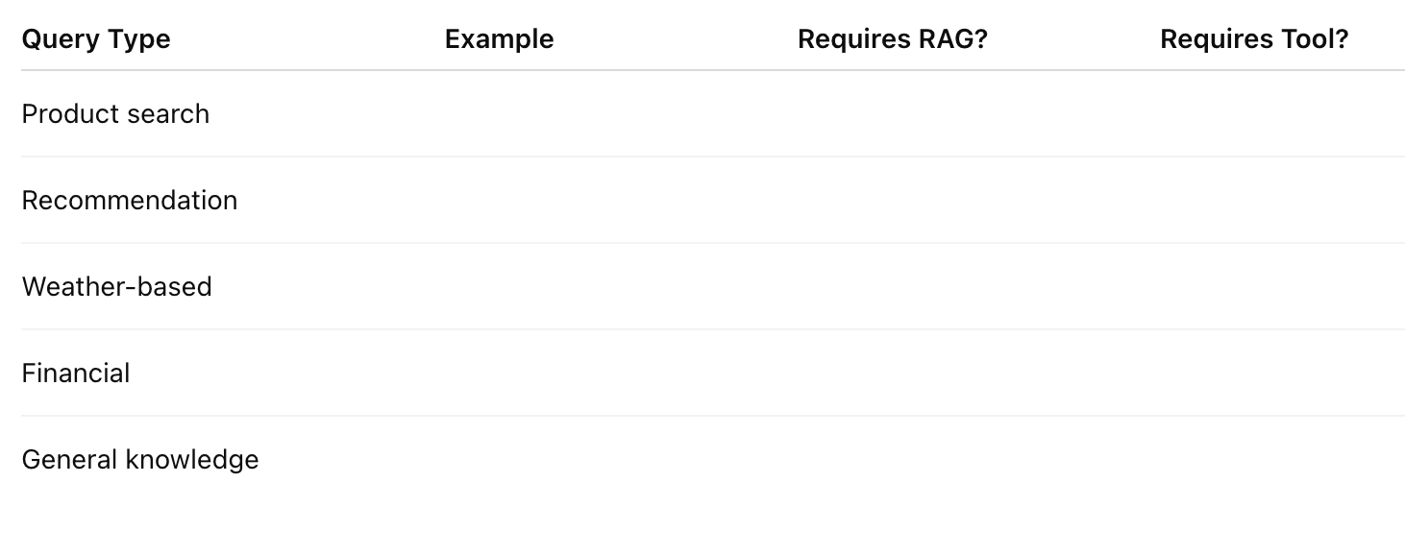

Section 2 — LLM Selection Decision

2.1 Model Requirements
What do you need from your LLM?
- Deterministic behavior?
- Tool calling?
- Large context window?
- Low latency?
- Cost optimization?
List requirements:

2.2 Model Choice
You must choose:
- GPT-4o-mini
- GPT-4o
- Other OpenAI model
Justify your selection:
Chosen Model:

Justification:
- Reasoning capability:
- Cost:
- Latency:
- Tool calling support:
- Context length:
Trade-offs:

Section 3 — Embedding Model Selection

3.1 Requirements
- Dimensionality?
- Cost constraints?
- Performance requirements?
- Multilingual support?

3.2 Embedding Model Decision
Options:
- text-embedding-3-small
- text-embedding-3-large
Chosen Model:

Justification:
- Cost per 1M tokens:
- Retrieval accuracy:
- Expected catalog size:
- Latency:

Section 4 — Vector Database Decision

4.1 Scale Estimation
Estimated product catalog size:

Expected growth rate:

Concurrent users:

4.2 Database Options
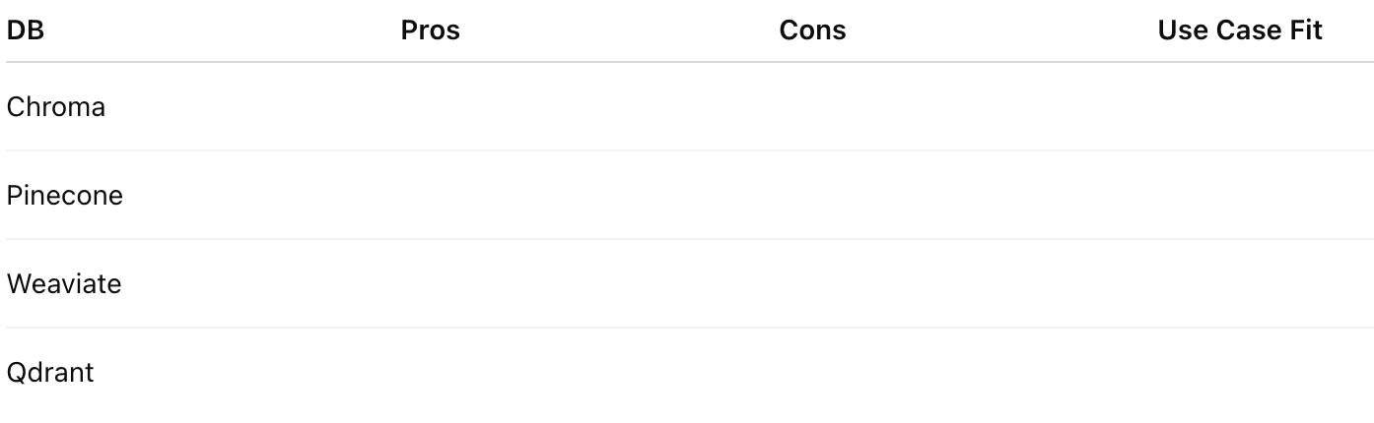

4.3 Decision
Selected Vector DB:

Justification:
- Scalability:
- Persistence:
- Metadata filtering:
- Cost:
- Operational complexity:

Section 5 — Chunking Strategy

5.1 Content Type
What are you chunking?
- Product descriptions?
- Reviews?
- FAQs?
- Specifications?

5.2 Chunk Size Decision
Chosen chunk size:

Overlap:

Why?

Trade-offs:
- Larger chunks:
- Smaller chunks:

Section 6 — Retrieval Strategy

6.1 Similarity Search
- Top K value:
- Similarity metric (cosine, dot product):
- Threshold filtering:
Justify:

6.2 Metadata Filtering
Will you filter by:
- Price?
- Category?
- Availability?
- Rating?
Explain logic:

Section 7 — Reranking Strategy

7.1 Do You Need Reranking?
When would reranking be necessary?
- High catalog volume?
- Low precision in top-K?
- Need higher recommendation accuracy?
Decision:
Yes / No
Justify:

7.2 Reranking Options

Selected Method:
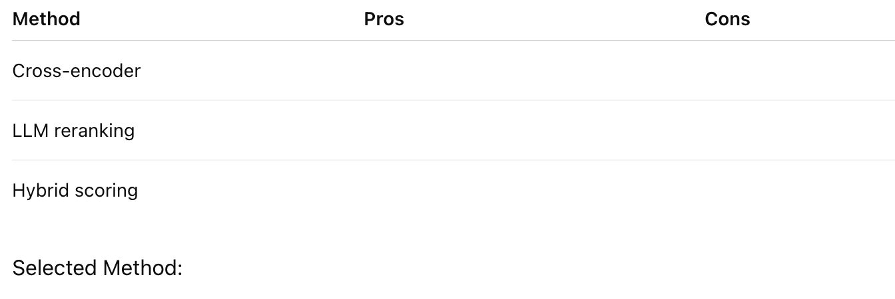

Justification:
- Latency impact:
- Accuracy gain:
- Cost impact:

Section 8 — Tool Selection Strategy

8.1 Required Tools
List all tools required:
- Weather
- Web Search (Serper)
- Inventory
- Calculator
- Interest
- Shipping estimator
Why is each tool necessary?
Tool:

Justification:

8.2 Tool Routing Strategy
Will routing be:
- Intent classifier-based?
- Fully LLM autonomous?
- Rule-based first, LLM second?
Selected approach:

Justification:

Section 9 — Fallback Strategy
If:
- No product found
- Low similarity score
- Out-of-stock product
What happens?
Fallback approach:

Why?

Section 10 — LCEL vs Direct API
Will you:
- Use LCEL pipelines?
- Use LangGraph?
- Use direct OpenAI APIs?
Decision:

Justification:
- Debugging clarity:
- Control:
- Maintainability:
- Team expertise:

Section 11 — Personalization
Will you:
- Use user embeddings?
- Use past purchases?
- Use session memory?
Explain personalization strategy:

Section 12 — Evaluation Strategy

12.1 Offline Evaluation
Metrics:
- Retrieval precision
- Recall
- MRR
- NDCG
Selected metrics:

12.2 Online Evaluation
- CTR improvement
- Conversion rate
- Bounce rate
- Tool usage frequency
Define KPIs:

Section 13 — Cost Analysis
Estimate:
- LLM cost per query
- Embedding cost
- Vector DB cost
- Tool API cost
Projected monthly cost:

Cost optimization strategies:

Section 14 — Risk Assessment
Identify risks:
- Hallucination
- Tool misuse
- Latency spikes
- API downtime
- Injection attacks
Mitigation strategy:

Section 15 — Final Architecture Justification
Summarize your final decisions:
LLM:

Embedding Model:

Vector DB:

Chunking Strategy:

Retrieval Strategy:

Reranking:

Tools:

Fallback:

Why this architecture is production-ready:

Final Reflection
Explain:
- Why your LLM choice is appropriate.
- Why your vector database scales.
- Why reranking is necessary or not.
- Why your tool routing strategy is safe.
- How you would scale to 10x traffic.
Write a structured justification:

Outcome
After completing this workbook, a You should be able to:
- Defend every architectural choice
- Explain trade-offs clearly
- Estimate cost and latency
- Design a scalable RAG + Tool system
- Justify reranking decisions
- Move confidently into implementation

